BULLETIN OF MARINE GEOLOGI (TITTLE IN ENGLISH)
(Less than 15 words, centered, font type Times New Roman (TNR), font size 16, single space)

JURNAL GEOLOGI KELAUTAN(IN BAHASA INDONESIA)
(Kurang dari 15 kata, di tengah, TNR 16, spasi tunggal, italic)
Yudi Darlan¹, Noor Cahyo Dwi Aryanto¹, Haryadi Permana²
¹Marine Geological Institute, Jl. Dr. Junjunan no.236, Bandung
²Research Centre for Geotechnology – LIPI, Indonesia, Komplek LIPI, Jl. Sangkuriang Bandung, 40135

darlanyudi@gmail.com, noor_aryanto@yahoo.com, permana@geotek.lipi.go.id

ABSTRACT
Contains neither pictures nor tables, 11 TNR, justified, single space, no more than 250 words. Summarize clearly background, aim and purpose of the research, location of the research, material and methods, results, discussions and conclusion.
Keywords: Contains of four to six words, separated by coma, 10 TNR, single space
ABSTRAK
Huruf TNR 11, spasi tunggal, tidak ada tabel atau gambar, tidak lebih dari 250 kata, ditulis italic. Merupakan versi bahasa Indonesia dari abstrak di atas (isi harus sama dengan Abstract).
Kata Kunci: Terdiri dari 4 sampai 6 kata, dipisahkan oleh koma, huruf TNR 10, spasi tunggal

INTRODUCTION (HEADING 1, 14 TNR, BOLD, UPPERCASE)
TNR, font size 11, single space, please describe clearly background, aim and objectives, problems, and the location of the research. It is better also to cite previous references correlated to this research, references can be cited as Susilohadi et al. (2009), Usman and Panuju (2013), Kenneth (2009).
If it is necessary, describe clearly and simply the geological regional information, including lithology, tectonic and geological structure.

Geological Setting (Heading 2, 11 TNR, Bold)
The geological setting can be separated in sub title.

METHODS (AND MATERIALS)
Consists of material for the research, describe clearly and systematically methods applied to this research.

RESULTS
Result can be displayed in words, figures, and tables. Figures can be displayed in both black and with or in colour. Figures should be readable with proportional explanation. All figures and tables should be cited in the text. The position of figure’s caption should be below the figures, table caption position is above the tables. Figure 1 is the example how to present figures, example of table can be seen in Table 1.
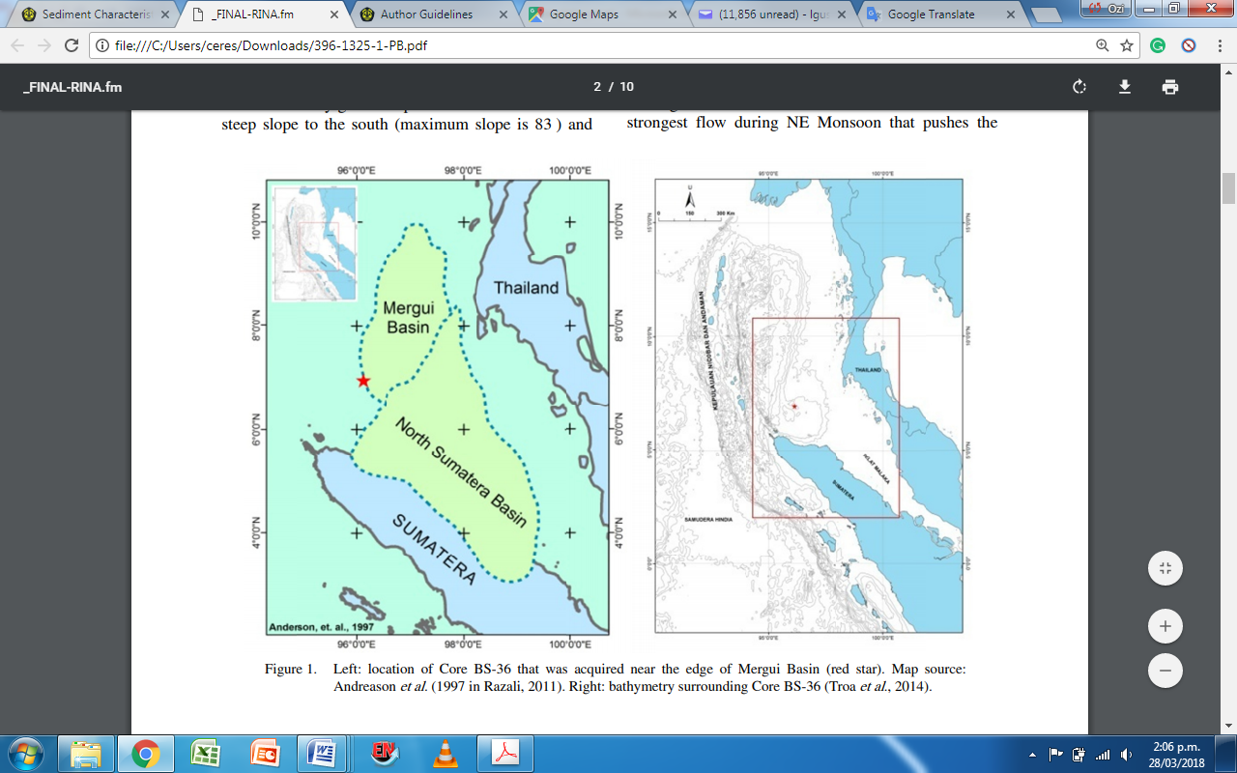

Figure 1. Example (figure from Zuraida et al., 2017)

DISCUSSIONS
Discussion explains about interpretation and analysis of the result, supported with figures/ map/graphs. It is better to correlate with previous research that are correlated.

CONCLUSSIONS
Consists of summary of the important results and interpretation obtained from the research, it is must be correlated to the abstract.

ACKNOWLEDGEMENTS
Acknowledge the source of research data and/or funding, cruise, vessel, etc., express appreciation and gratitude to person/institution who help during research and writing but are not considered as co-authors.

REFERENCES
References written in this part should be mentioned in the text. Please respect to the author guideline of the references format. If it is written by more than one author, all authors should be written in the references, instead of using et al. References are written in alphabetical order.
Below are some samples of references in the correct format of this bulletin.
Table 1. Distribution of benthic foraminifera (From: Zallesa et al., 2014)

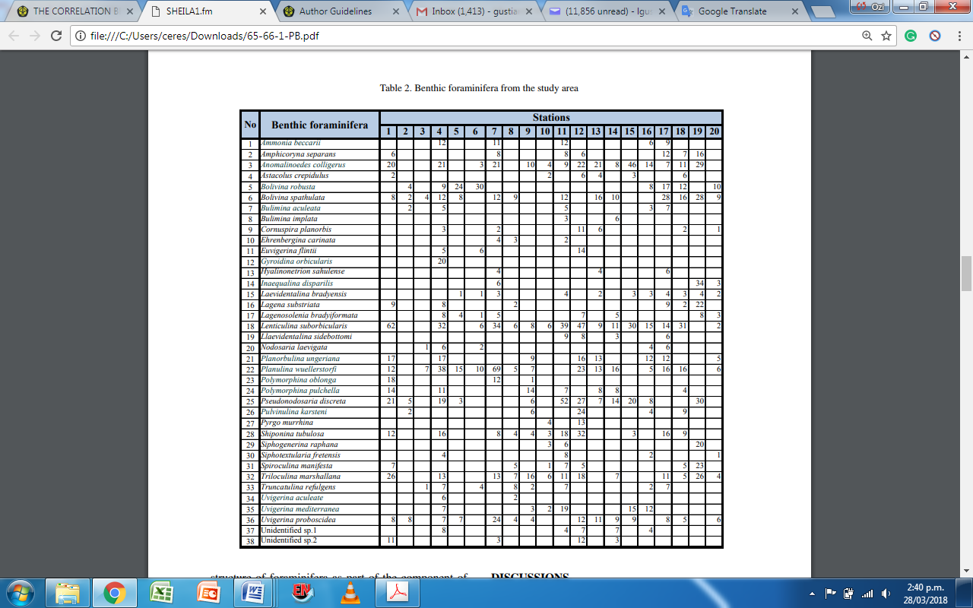
Book:
Kennett, J.P., 1981. Marine Geology. Prentice Hall, 813p.
Journal:
Usman, E., and Panuju, 2013. Study of Gas Potency Based on Gravity Anomaly Modeling And Seismic Profile Analysis at Banggai-Sula Basin. Bulletin of the Marine Geology, 28 (2): 51-60.
Susilohadi, S., Gaedicke, C., and Djajadihardja, Y.S., 2009. Structures and sedimentary deposition in the Sunda Strait, Indonesia. Tectonophysics, 467(1):55-71.
Special Issue:
Kenneth, S. J., 2009. Marine biogeochemistry in 2025. In: D. Glickson (Editor), Oceanography in 2025: Proceedings of a workshop. The National Academic Press, Washington D. C.: 130 – 134.
Unpublished Reports:
Darlan, Y., Kamiludin, U., Kurnio, H., Rahardian, R., Hutagaol, J. P., Sianipar, A. H., dan Sinaga, A. C., 2005. Eksplorasi prospektif gas biogenik kelautan di Perairan Muara Kakap dan sekitarnya - Kalimantan Barat. Pusat Penelitian dan Pengembangan Geologi Kelautan, Bandung, Badan Penelitian dan Pengembangan Energi dan Sumberdaya Mineral, Departemen Energi dan Sumberdaya Mineral. Internal report, 104p. Unpublished.
Information from internet:
<http://palaeo-electronica.org/2003_1/benthic/issue1_03.htm> [Accessed at 30 November 2011].
Butzin et al., 2005, Global reservoir age database, http://radiocarbon.LDEO.columbia.edu/, accessed at 2014-09-06.

